Build Guide for Microsoft Office Project Server 2007

Microsoft® Office Enterprise Project Management Solution
Build Guide



AstroWix Corporation
39510 Paseo Padre Parkway, Suite 290, Fremont CA 94538, USA
Phone: +1 866 EPM OPM3, Fax: +1 510 791 1111
Email: info@astrowix.com



AstroWix India Project Solutions Pvt. Ltd.
Delhi NCR Office
A-53, Sector 16
Noida 201 301, INDIA
Phone: +91 120 431 5760, Fax: +91 120 431 5766
Email: info@astrowix.com
Bangalore Office
484, II Cross, 25th Main
BTM Layout II Stage
Bangalore - 560 076, INDIA
Phone: +91 80 2678 5916
Email: info@astrowix.com

Table of Contents
Introduction 5
What Can You Learn from This Document? 5
Who Should Read This Document? 5
IT Administrators 5
Database Administrators 5
Deployment Planners 5
Overview of Project Server 2007 6
Project Server 2007 Components 6
Project Server 2007 requires the services 7
EPM Solution Architecture 8
Client Tier 8
Middle Tier 9
Database Tier 9
Installation Roadmaps for [Company Name] 11
EPM Architecture for [Company Name] 11
Software Configuration 13
Installation Guideline for EPM Server 15
Installing SQL Server 2005 17
Configure the Farm Services 30
Create an extended Web site to host the SharePoint team site 33
Create the Shared Services Provider 36
Install Office Project Server 2007 to the farm 39
Configure Microsoft Office Project Professional 2007 42
Configure Microsoft Office Project Web Access 43
Backup and Restore Project Server 2007 44
Restoring a Project Server 2007 deployment 48

Document Control Sheet

Document Author (s)
Author's Name | Role | Description
[Technical Consultant Name] | Technical Consultant | AstroWix

Document Review
Reviewed By | Title | Description

Document Approval
Approved By | Title | Description

Introduction
The Build Guide for [COMPANY NAME] is designed to help [COMPANY NAME] Understand the tasks involved in installing Microsoft® Office Project Server 2007 and other related components.

What Can You Learn from This Document?
This guide covers the installation of Microsoft Office Project Server 2007 and its related components. The following topics are covered:
Preparing your servers for installation of Project Server 2007
Microsoft Windows® SharePoint® Services

Other related components

Preparing your servers for installation of Microsoft SQL Server 2005
Preparing your servers for installation of SQL Server Analysis Server
Deploying your Project Server 2007 database, automatically, by means of the Project Server Setup program.

Who Should Read This Document?
This guide is designed to benefit the following professionals:

IT Administrators
Those individuals who are responsible for installing Project Server 2007 and its related components.

Database Administrators
Those individuals who are responsible for database maintenance.

Deployment Planners
Those individuals who plan the deployment of Project Server 2007 within organization.

Overview of Project Server 2007
Microsoft® Office Project Server 2007 is designed to support collaboration between project managers who are using Microsoft Office Project Professional 2007 and team members who are using Microsoft Office Project Web Access 2007. The Microsoft Office Enterprise Project Management (EPM) Solution is an integrated system that includes Project Professional 2007, Project Web Access 2007, and Project Server 2007.
Project Server 2007 provides timesheets, status reports, portfolio analysis and modeling, enterprise resources, and enterprise templates. When integrated with Microsoft Windows® SharePoint® Services, Project Server 2007 provides document management and issues and risk tracking features.
Users access Project Server 2007 by means of Project Web Access, a browser-based client that enables team members, resource managers, and executives to enter and view timesheet information and view portfolio reports. Project managers can create projects or create or modify the Enterprise Resource Pool by using Project Professional and save that data to the Project Server database.
Project Server 2007 is flexible and is designed to enable you to extend your EPM Solution. You can begin by using a limited number of enterprise features and then add additional features as needed.
The Office EPM Solution includes the following servers from the Microsoft Office Project 2007 family to provide organizations with an end-to-end project portfolio management (PPM) solution:
Microsoft Office Project Server 2007
This guide covers how these servers interact with each other using a bidirectional gateway, as well as how their functions are exposed through their Web clients. Further, Microsoft Office Project Professional 2007 provides a rich desktop client for Office Project Server 2007.

Project Server 2007 Components

Project Server 2007 consists of the following software components:
- Project Server Front-End service Handles all Project Web Access and Project Data
Service requests.
- View Processing Generates static views of published data for Project Web Access.
- Session Manager Handles the session-state information for each client that is connecting to Project Server 2007 from Project Web Access.

Project Server 2007 requires the services

- Internet Information Services (IIS) 5.0 or later Provides the foundation for secure and scalable Web-based solutions. IIS is included as part of the Microsoft Windows 2000 Server and Microsoft Windows Server™ 2007 operating systems.

- Microsoft SQL Server™ 2005 Provides database management for users who want to take advantage of all enterprise functionality that is built in to Project Server 2007 in a scalable environmSE. Both SQL Server 2005 Enterprise Edition and SQL Server 2005 Standard Edition support the enterprise functionality of Project Server 2007, but only SQL Server 2005 Enterprise Edition supports advanced deployment features such as failover or HTTP Internet support. You must install SQL Server 2005 before you can install Project Server 2007 or configure Windows SharePoint Services for Project Server 2007.

- SQL Server 2005 Analysis Services Provides online analytical processing (OLAP) services, which are required for the Portfolio Analyzer feature of Project Server 2007. The Portfolio Analyzer feature is only available as an enterprise feature of Project Server 2007.

- Project Professional Provides enterprise-wide project and resource management capabilities, collaboration functionality, and scenario analysis tools for organizations that require an enterprise project management solution. To access Project Server 2007, Project Professional 2007 has the following Internet browser requirements:

  - Internet Explorer 5.01 with SP3 or later
  - Internet Explorer 5.5 with SP2 or later
  - Internet Explorer 6 with SP1 or later (recommended)

- The Microsoft Office Project Add-in for Outlook® Enables users to keep track of tasks that are assigned to them in projects. Tasks can be tracked in Microsoft Outlook 2000 or later (or Outlook Web Access in a limited capacity). The Outlook Integration add-in is available from the Project Web Access Home page.

- Microsoft Internet Explorer version 6.0 (or later) Enables access to the Project Web Access user interface (UI). Internet Explorer 6.0 with latest service pack in order to use all available Project Web Access features.

EPM Solution Architecture
The Microsoft EPM Solution is based on a common three-tiered architecture, consisting of a client tier, an application tier, and a database tier.

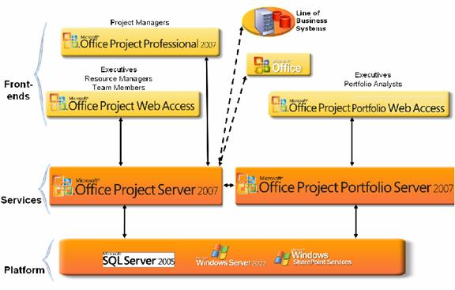

Client Tier

The front-end tier includes third-party applications as well as Project Professional and Project Web Access. Project Web Access uses Internet Explorer to display Microsoft ASP.NET 2.0 pages. The Project Web Access pages use standard Windows SharePoint Services 3.0 Web Parts that communicate with the PSI. Client applications on separate computers call the PSI through proxies to the PSI Web services. Client applications and back-end components of line-of-business (LOB) Web applications use PSI proxies to make direct calls to the PSI Web services if they can access the Project Server computer. If applications do not have direct intranet access to Project Server, they can use a Project Web Access server in a perimeter network.

Middle Tier

The middle tier includes the PSI and the business logic layer, which consists of logical business objects that represent Project Server business entities. Business objects include Project, Task, Resource, Assignment, and so forth. The PSI and the business logic tier are tightly coupled and are located on the same server. A client application calls the PSI Web services, and the PSI invokes business objects in the business logic tier.

Database Tier

All Project Servers Data is stored in Microsoft SQL Server databases, which can be located on separate servers. The Project Server databases are factored into the following stores: Draft, Published, Archive, and Reporting. The Project Web Access components of Project Server also use the Windows SharePoint Services configuration database for project site setup and the content database for Project site content such as management settings, documents, and lists of issues, risks, and Commitments. The Windows SharePoint Services configuration and content data stores support Additional features for project management, such as Project templates and workspaces, workflow, Team collaboration and reporting.
Security account requirements

During the installation and configuration, you must specify the following user accounts and passwords:

Windows SharePoint Services Service Account

This account is used to create the Windows SharePoint Services Configuration database in SQL Server to configure the farm and will become the administrator to the Central Administration page. This is a unique domain user account that you can specify as the Windows SharePoint Services version 3 service accounts. This user account is used to access your SharePoint configuration database. It also acts as the application pool identity for the SharePoint Central Administration application pool and it is the account under which the Windows SharePoint Services Timer service runs. The SharePoint Products and Technologies Configuration Wizard adds this account to the SQL Server Logins, the SQL Server Database Creator server role, and the SQL Server Security Administrators server role. It is recommended that you follow the principle of least privilege and do not make this user account a member of any particular security group on your front-end servers or your back-end servers.

The Application Pool Security Account

This account is a security account under which an Application pool is run. Application pools are an Internet Information Services 6.0 feature that enables you to use an isolated process to run Web applications. The user account must be a domain user account, but the user account does not have to be a member of any particular security group. It is recommended that you use the principle of least privilege and select a unique user account that does not have administrative rights on your front-end servers or on your back-end database servers. You can use the user account that you specified as the Windows SharePoint Services version 3 service accounts; however, if that user account is a member of a security group that has administrative rights on your front-end servers or your back-end database servers, you will not be following the principle of least privilege. The user name must be in the format DOMAIN\username.

There are two Application Pool security accounts that are needed during the provisioning process:
- One account is needed during the provisioning process in which you need to create an unextended Web site to host the Shared Service Provider. It will be the account that will be granted rights to the Project Server databases and will also be the account under which the Project Server Interface is run.

- The other account is needed to create an extended Web site to host the Project Web Access SharePoint Team site. This site is the Windows SharePoint Services content Web application that hosts the Project Web Access sites and project workspaces on the computer on which the Web front end is running

Site Collection Owner Account

The person with this account will have administrative rights over the Windows SharePoint Services site collection created to host the SharePoint Team site. A site collection is a group of sites built on Microsoft Windows SharePoint Services that all exist under a top-level site. This account is entered specifying a primary site collection owner when creating a new Windows SharePoint Services site collection after creating the extended Web site to host the SharePoint Team Site. During this process, the top-level site for this initial site collection is created. This can be the same user account that you specified as the Windows SharePoint Services service account.

Shared Service Provider Administrator

This account is needed to create the Shared Service Provider. It needs to have Database Creator and Security Administrator permissions on SQL Server. For, it will also need to be a box administrator.

Project Server Instance Administrator Account

The person with this account will be given administrator rights to the instance of Office Project Server 2007 that you are installing. You will need to enter this account information when installing Office Project Server 2007 to the farm. This account must be a valid domain user (unless you are using forms authentication).

Installation Roadmaps for [Company Name]

This section describes three examples of farm deployments for Office Project Server 2007. Each example includes a roadmap of, or high-level steps for, the installation process for your deployment. Identify the deployment roadmap in this article that most closely matches the architecture that you require for your organization, and then follow associated the procedures in to complete your installation. The high-level steps can be followed in more detail in the "Office Project Server 2007 Installation Procedures" section of this article.

EPM Architecture for [Company Name]

A single computer deployment can support a small -sized organization and can be used by a large organization to test Project Server 2007. A single computer deployment supports up to 50 users, but is not ideal for a large-scale production environment.

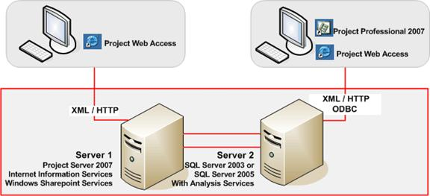
XML/HTTP
ODBC
XML/HTTP


EPM-SERVER
Operating System
Windows Server 2003 Ent.
Application Server
Project Server 2007
Internet Information Services
IIS
Windows Share Point Services V3
Database
SQL Server 2005 with Analysis Services
EPM-SERVER

Hardware Configuration

Project Server Configuration

Server [COMPANY NAME] | Configuration
Server Name | [Server Name]
Processor 1 | [Intel Xeon Dual Core 1.8 GHZ]
Processor 2 | [Intel Xeon Dual Core 1.8 GHZ]
HDD | [Capacity]
RAM | [3 GB]
Number of Network interface Cards | [2]
IP Address Details | [10.0.8.94]
Default Gateway Details | [10.0.0.1]
Preferred DNS Server | [10.0.8.72/82]
Alternate DNS Server Detail | [10.0.8.82]
Mail Server Name/ IP | [Mail Server Name/IP Address]

- List the User details

User Name |  | Full Name |  | Description |  | Password |  | Groups Belonged to
Domain Name\epmadmin |  | EPM Admin |  | Windows Administrator |  | ******** |  | Administrator

Software Configuration

Dependency | Requirement | Optional
Operating system | Windows Server 2003 Enterprise Edition SP1 or later (32 or 64-bit)
Database server | SQL Server 2005  SQL Server Analysis Services  Note The SQL Server Analysis Services and SQL Server Reporting Services versions should be matched with the SQL Server version. | SQL Server Reporting Services
Windows SharePoint Services version 3 | Version 3.0 or later  Note You do not need to install Windows SharePoint Services version 3 prior to installing Office Project Server 2007. Windows SharePoint Services version 3 is installed with the Office Project Server 2007installation. Windows SharePoint Services version 3 also is not required on the database server in a two-computer small farm configuration.
.NET Framework | Version 3.0 or later  Note Not required on the database server.
ASP.NET | Version 2.0.50727 or later  Note Not required on the database server in a two-computer small farm configuration. ASP.NET should be updated automatically when the .NET Framework is updated, as long as IIS is enabled on the computer. You can check the version that you have by starting Internet Information Services Manager and going to the Web Services Extensions folder.  Windows Workflow Foundation component. It comes with .Net Framework 3.0
Other | If you need to send e-mail notification, you need a Simple Mail Transfer Protocol (SMTP) Server.  If you need to receive e-mail notifications, you need a mail client that can receive the mail via the SMTP Server, such as:.  - Post Office Protocol 3 (POP 3)  - Internet Message Access Protocol 4 (IMAP4)  - Microsoft Messaging Application Programming Interface (MAPI)–compliant messaging software

Installation Guideline for EPM Server

Installing Windows Components

Steps to install windows components

- Click On Start
- Select Settings
- Control Panel selects Add-or-Remove Programs
- Click Add/Remove Windows Components
- Uncheck IE enhance security configuration
- Check Application Server—Click on Details button
  - Check Asp.net
  - Check IIS ----Click on details
        - Check IIS manager
        - Check World Wide Web Service---Click on detail
          - check Active Server Pages
          - check Internet Data Connector
          - check Server Side Includes
          - Check Webdav01 Publishing
          - World Web Service

- check at run inetmgr

Install the .NET Framework 3.0 and turn on ASP.NET 2.0

Steps to install .NET Framework version 3.0

- In your Web browser, go to the Microsoft. NET Framework version 3.0 site.
- Click Download, and then click Run.
- On the Welcome to Microsoft. NET Framework Setup page, click Next.
- Select the I accept the terms of the License Agreement check box, and then click Install.
- Click Finish.

To enable ASP.NET 2.0.50727 in Internet Information Services (IIS)

- Click Start, and then click Run.
- In the Open box, type inetmgr, and then click OK.
- In the left pane of the Internet Information Services (IIS) Manager, select the computer on which you want to enable ASP.NET.
- In the right pane, double-click the Web Service Extensions folder.
- Right-click ASP.NET v2.0.50727, and then select Allow.

—Or—

- Click Start, and then click Run.
- In the Open box, type cmd, and then click OK.
- Change to the following directory: %windir%\Microsoft.net\Framework\v2.0.50727.
- Run the following command: aspnet_regiis.exe –i –enable.

Installing SQL Server 2005

Steps to install SQL Server 2005

- Installing a Named Instance of SQL Server 2005
- Place the SQL Server 2005 installation CD in the CD-ROM drive.
- The installation menu should come up automatically. If it does not, select Start | Run, type D:\AUTORUN.EXE (where D is the designation of your CD-ROM drive), and then click OK.
- Accept the Licensing Terms and Conditions in End User Licensing Agreement, and then click Next.
- On the Installing Prerequisites page, click the Install button to install any prerequisite software, such as:

    - NET Framework 3.0
    - Microsoft SQL Native Client
    - Microsoft SQL Server 2005 Setup Support files.

- On the Welcome page, click Next.
- Installing SQL Server 2005 Standard Edition
- On the System Configuration Check page, click Next.

Important

- You might see Warnings for the IIS Feature Requirement and the ASP .NET Version Registration Requirement. These components are not required for Portfolio Center and are most commonly seen on server operating systems like Windows Server 2003. You can ignore these warnings.

- You will see Errors if you are missing components necessary for SQL Server installation. In this situation, you’ll see an Exit button instead of the Next button in the image above. If you encounter problems with the installation that forces you to exit, see the RequirementsSQL2005.HTM file on the SQL Server 2005 installation disk for more information about components needed for SQL Server 2005.

In the Registration Information screen, enter the following information:
♦ Name
♦ Company
♦ Registration key

- Click Next.
- On the Components to Install page, check SQL Server Database Services, Analysis Services, Reporting Services, and Client Tool and Workstation components, Books Online and development Tools, and then click Advanced.

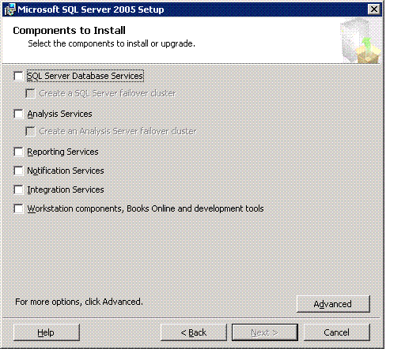

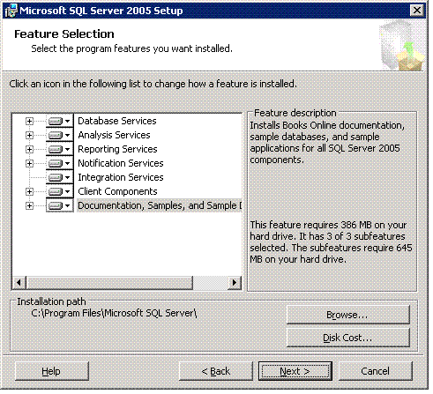

- On the Instance Name screen, select Named Instance, and then enter “EPM” in the field below.

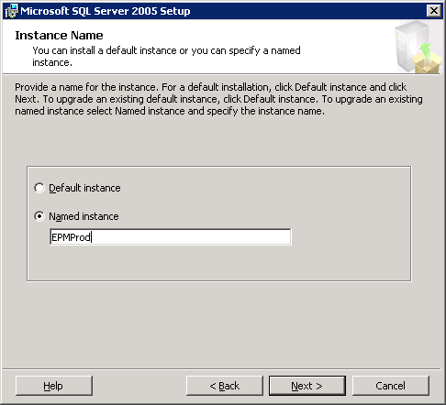

- Click Next.
- On the Service Account screen, select the following options:

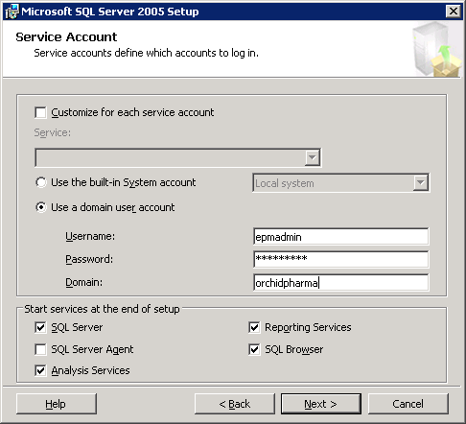

- In the Start Services at the end of Setup box, check SQL Server and SQL Browser.
- Click Next.
- On the Authentication Mode screen, select Mixed Mode Authentication, and then click Next.
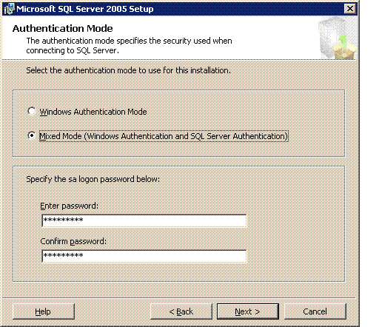

- On the Collation Settings screen, accept the default select, and then click Next.

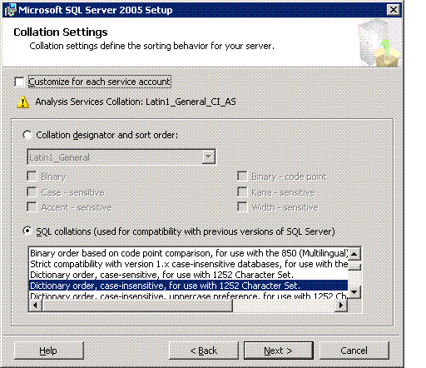

- Finish

Install the Office Project Server 2007 binary files

When installing the Office Project Server 2007 binary files (or "bits"), you will have the option to configure the installation to deploy both the Application and Web Front end tier to the computer, or to install just the Web Front End tier.

- Navigate to the installation location for Office Project Server 2007, and then double-click the Setup.exe file to begin Setup.
- On the Enter Product Key page, type the 25-character product key, and then click Continue.
- On the End User License Agreement page, view the terms of the agreement. Select I accept the terms of the agreement, and then click Continue.
- On the Choose the Installation you Want page, click Advanced.
- On the next screen, on the Server Type tab, select Complete to choose to install the Web front-end server and application server.

- On the File Location tab, you can specify the location to which you want the bits to be installed. The default location is C:\Program Files\Microsoft Office Servers.
- Click Install Now. The Office Project Server 2007 application tier and Web tier components are installed onto the computer.

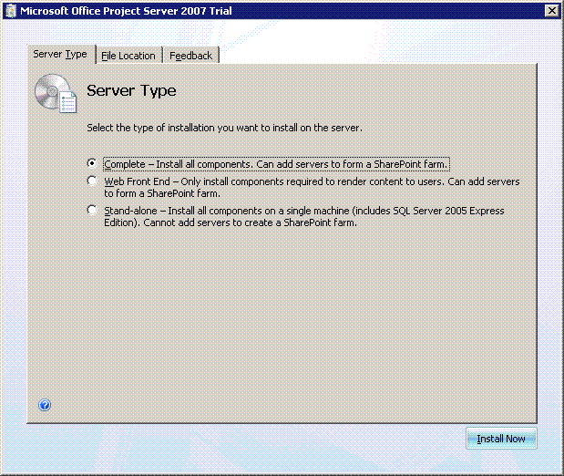
- When installation of the binary files is completed, the Setup Complete page is displayed and prompts you to complete the configuration of your server. If you want to continue, verify that Run the SharePoint Products and Technologies Configuration Wizard now is selected, and then click Close.

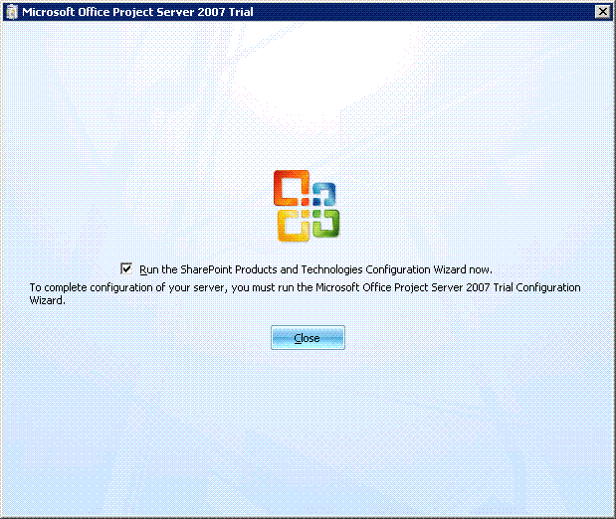

Run post-setup configuration to configure the farm

Post-setup configuration allows you to create the configuration database as well as specify whether you are creating a new server farm or joining an existing one.

- The Welcome to SharePoint Products and Technologies page lists information that is required from you during configuration, including:
  - Name of the database server and database where the server farm configuration data will be stored. Only the database server name is required if you plan to use an existing database for a Office Project Server 2007 farm.

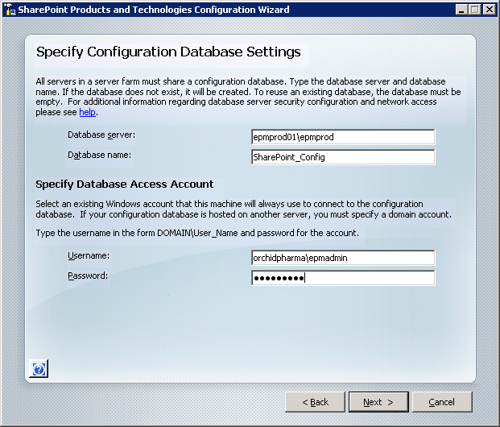

- User name and password for the database access account that will administer the server farm.
- Please have this information available during post-setup configuration.

- Click Next.
A message alerts you that specified services might need to be restarted or reset during the installation. Click Yes.

- On the Connect to a Server Farm page, select No, I want to create a new server farm.
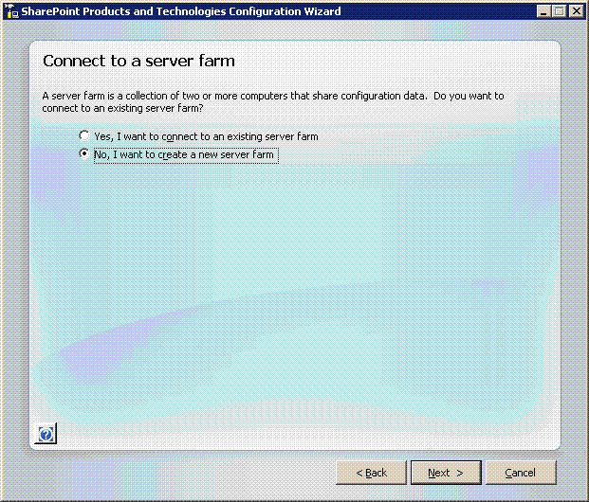

- Click Next.
- On the Specify Configuration Database Settings page, use the information you gathered earlier to specify the name of the computer running SQL Server and the name of the configuration database, and to specify a Windows account that the computer will use to connect to the configuration database.

- In the Database server box, type the name of the computer running SQL Server on which the database will be created.
- In the Database name box, type the name that you want to give the configuration database. The default entry is SharePoint_Config.
- In the Specify Database Access Account section, in the Username box, type the name of the Windows account you want to use to access the configuration database. This account must have access to the computer running SQL Server to create the configuration database and must be a member of the Power Users group on that computer.

Note This is a unique domain user account that you can specify as the Windows SharePoint Services version 3 service account. This user account is used to access your SharePoint configuration database. It also acts as the application pool identity for the SharePoint Central Administration application pool and it is the account under which the Windows SharePoint Services Timer service runs. The SharePoint Products and Technologies Configuration Wizard adds this account to the SQL Server Logins, the SQL Server Database Creator server role, and the SQL Server Security Administrators server role. It is recommended that you follow the principle of least privilege and do not make this user account a member of any particular security group on your front-end servers or your back-end servers.
- In the Password box, type the password for this account.
- Click Next.

- On the Configure SharePoint Central Administration Web Application page, in the Configure Security Settings section, select either Negotiate (Kerberos) or NTLM, depending on your network configuration. If you are uncertain, contact your network administrator. Click Next.
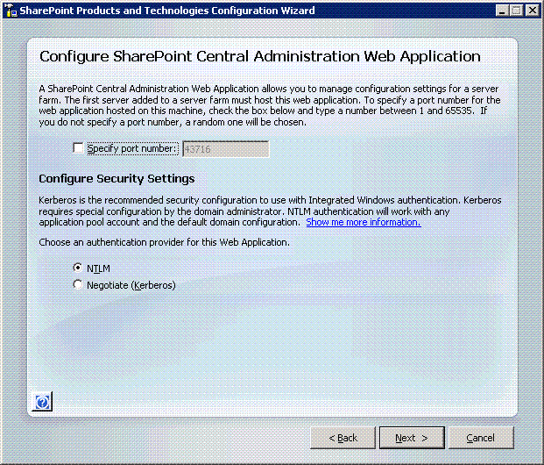

- On the Completing the SharePoint Products and Technologies Configuration Wizard page, verify that configuration settings information is correct. Click Next.
- When configuration is finished, the Configuration Successful page displays the configuration settings. Click Finish. This will automatically start up the Central Administration page.

Configure the Farm Services

The following procedures use the Central Administration page to start the Project Application Service and the Windows SharePoint Services Web Application. This step initially enables the Project Server Application and Web Front End tiers on the server.

  - On the Central Administration page top navigation, click Operations.

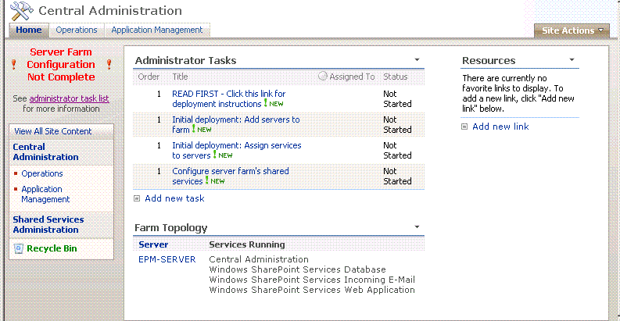

  - On the Operations page, in the Topology and Services section, select Services on server.

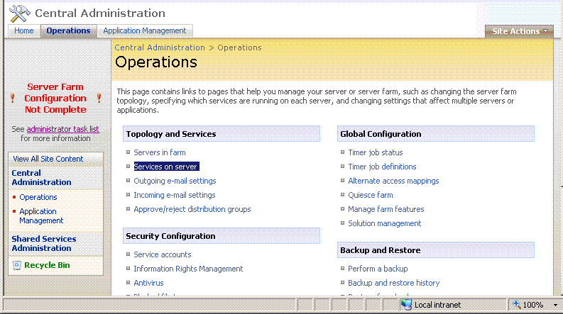

  - On the Services on Server page for this computer, from the Service list find Project Application Service. In the same row under the Action column, click Start.

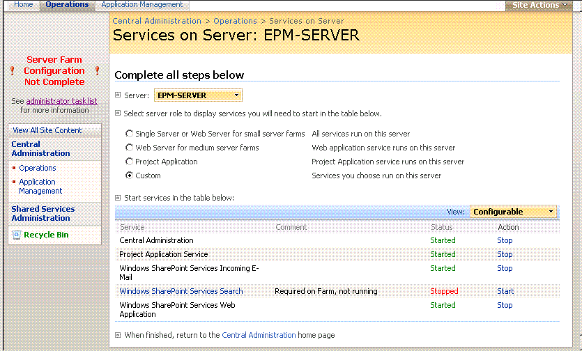

  - From the Service list find Windows SharePoint Services Web Application. In the same row under the Action column, click Start.

Note: If you want to have search capabilities, you will also need to enable the Windows SharePoint Services Help Search service. Enabling this service takes you to the SharePoint Services Search Settings page where you have to choose accounts for the search service and for content access, specify the search database server and name (defaults are suggested for you), and also configure the indexing schedule. It should also be noted that if you enable search it can be a system intensive process.

  - To see whether the status has changed to Started, you might need to refresh the page.

Create an extended Web site to host the SharePoint team site

The following procedures allows you to create the Project Web Access Web application and then extend it. During this process you create a new Web site, create the site collection for Project Web Access, and extend the root site. When finished, you will have a new top-level site for the site collection (although this site will contain no data at this point).

- On the Central Administration page top navigation, click Application Management.
- On the Application Management page, in the SharePoint Web Application Management section, click Create or extend Web application.

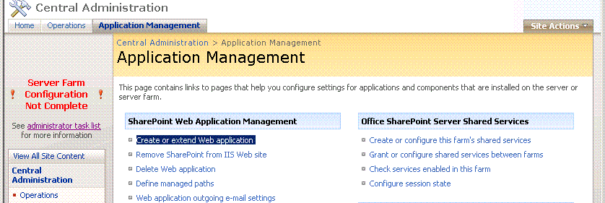

- On the Create or Extend Web Application page, in the Adding a SharePoint Web Application section, select Create a new Web Application.

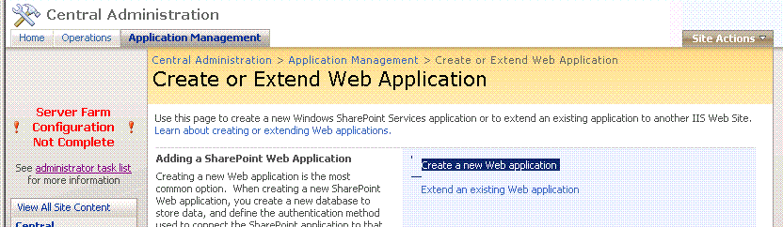

- On the Create New Web Application page, do the following:

- In the IIS Web Site section, select Use an existing IIS web site, and then select the existing Web site that you want to use from the list.

Note: You might need to create another Web site so that host headers are not needed and you do not have to remember to type the port number as a part of the URL. If you do this, make sure the site is assigned to port 80. For example, you might want to use a site other than the Default Web Site. To make things easiest, however, use port 80.

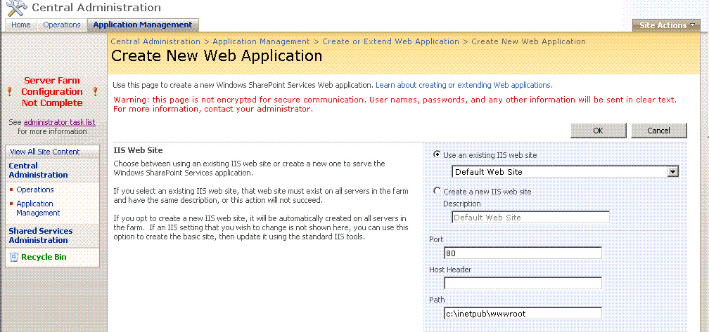

- In the Security Configuration section, under Authentication provider, select either Negotiate (Kerberos) or NTLM, depending on your network. If you are uncertain, contact your network administrator.

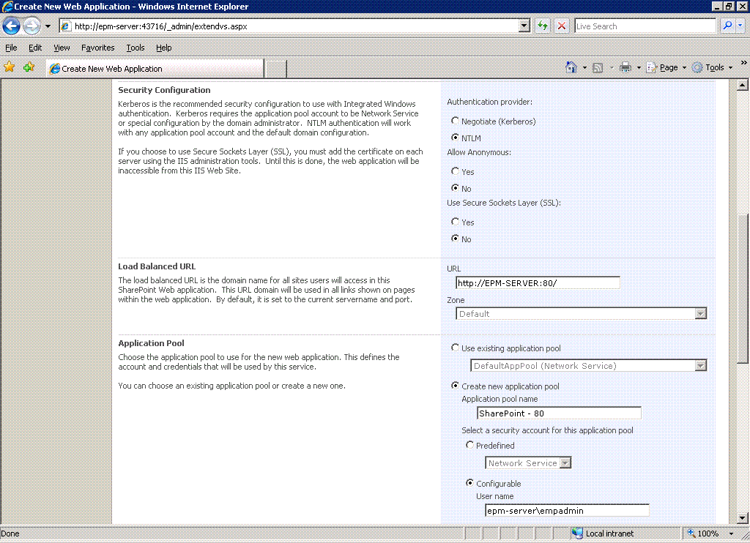

- In the Application Pool section, select Create new application pool.

- In the Application pool name box, a unique name is automatically generated based on the extended Web site you selected. You can use this entry or you can type another unique name.

- Select Configurable, and then, in the User name box, type the Windows account of the farm administrator. In the Password box, type the password for the account.
Note This user account must be a domain user account, but the user account does not have to be a member of any particular security group. It is recommended that you use the principle of least privilege and select a unique user account that does not have administrative rights on your front-end servers or on your back-end database servers. You can use the user account that you specified as the Windows SharePoint Services version 3 service accounts however, if that user account is a member of a security group that has administrative rights on your front-end servers or your back-end database servers, you will not be following the principle of least privilege. The user name must be in the format DOMAIN\username.

- Do not change any of the other default entries on this page, and then click OK.

- On the Application Created page that appears, select Create a new Windows SharePoint Services site collection.
- On the Create Site Collection page, do the following:

- Enter a title in the Title field. The title will be displayed on each page of the site, so you might want to title it similarly to Microsoft Project Web Access.

- In the Web Site Address section, click Create Site at this URL, and then select (root) from the list.
- In the Primary Site Collection Administrator section, type the user name of the site collection administrator in the corresponding field (you can do this for the secondary site administrator as well).

Note This can be the Windows SharePoint Services Service account

- Do not make any changes to the Quota Template section.

- In the Template Selection section, in the Select a template list, select the template you want to use when the top-level site of the site collection is created, and then click OK.

- On the Top-Level Site Successfully Created page, the URL for the new, empty top-level site is displayed. Click OK to return to the Central Administration page.

Create the Shared Services Provider

The following procedures allow you to create the Shared Service Provider using the Shared Service Provider Web application you created previously.

- On the Central Administration page top navigation, click Application Management.

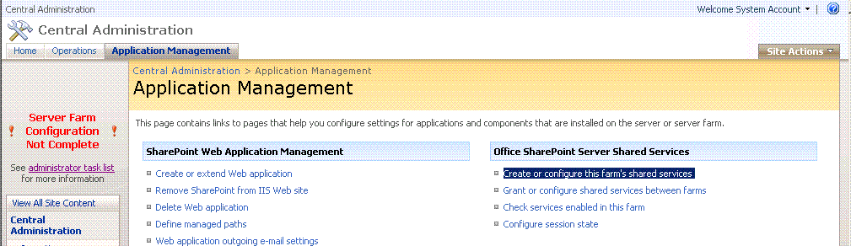

- On the Application Management page, in the Office SharePoint Server Shared Services section, click Create or Configure this Farm's Shared Services.
- On the Manage this Farm's Shared Services page, click New SSP.

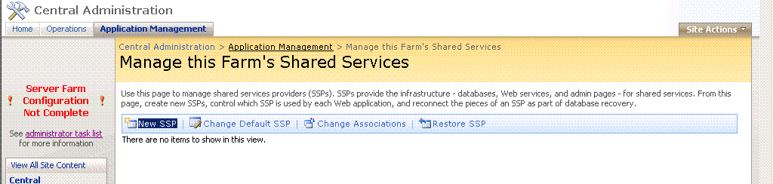

- On the New Shared Services Provider page, do the following:

- In the SSP Name section, in the Web Application list, select the Web application that you created when you created the unextended Web site to host the Shared Services Provider (for example, SharePoint (3915)).
Note Do not select the Default Web Site, Central Administration site, or any site associated with port 80 from the drop-down list.

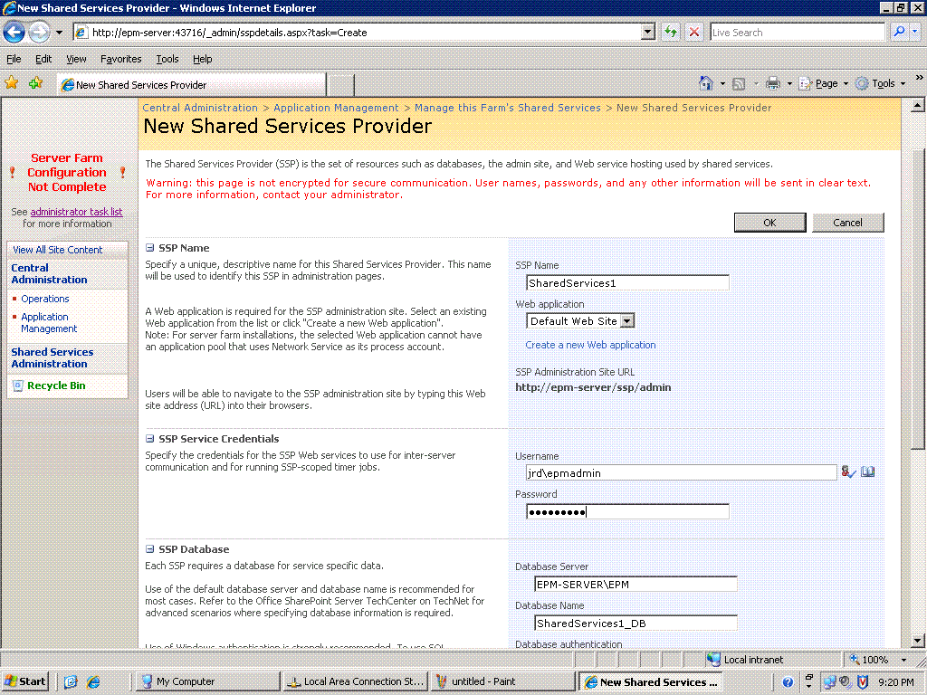

- In the SSP Service Credentials section, type the name and password for a Windows user who is the SSP administrator into the corresponding boxes.

Note It needs to have Database Creator and Security Administrator permissions on SQL Server. For , it will also need to be a box administrator.

- In the SSP Search and Database section, the database server name will automatically be the same as for the SharePoint Config database. The database names will also be automatically generated for you. You do not need to change these settings, but you can if you want.

- Click OK.
Note This process might take several minutes to complete.
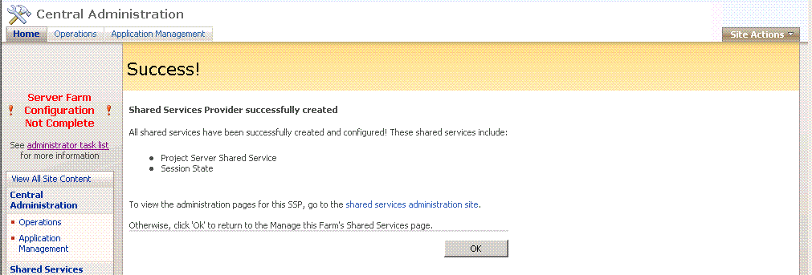

- After the SSP is successfully created, the Success! page is displayed. Click OK to go to the Manage this Farm's Shared Services page needed for the next section.

Install Office Project Server 2007 to the farm

This final procedure allows you to create the Project Web Access instance on the farm. During this process, you are able to specify the Project Server Administrator account, point to the database server that will be used to host the Office Project Server 2007 databases, and name the Office Project Server 2007 databases

- On the Manage this Farm's Shared Services page, in the SSP Name list, click the shared service you just created listed under SSP Name.

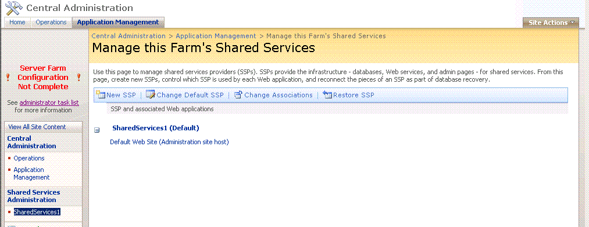

- On the home page for this core service, in the Project Server section, click Project Web Access Sites.

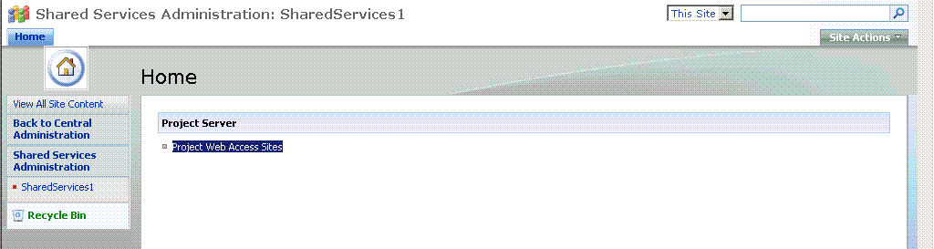

- On the Manage Project Web Access page, click Create PWA Site.

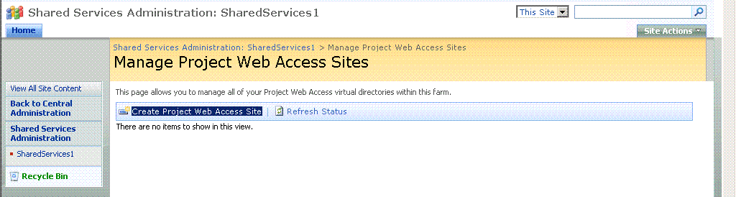

- On the Create a New Project Web Access page, do the following:

- In the Project Web Access Site Location section, from the SharePoint Web Application to host PWA list, select the name of the extended Web site. Do not select the unextended Web site being used for the Shared Service Provider.

- In the PWA path box, the default name of the Project Web Access path appears (Project Server). You can type a different name if you want.

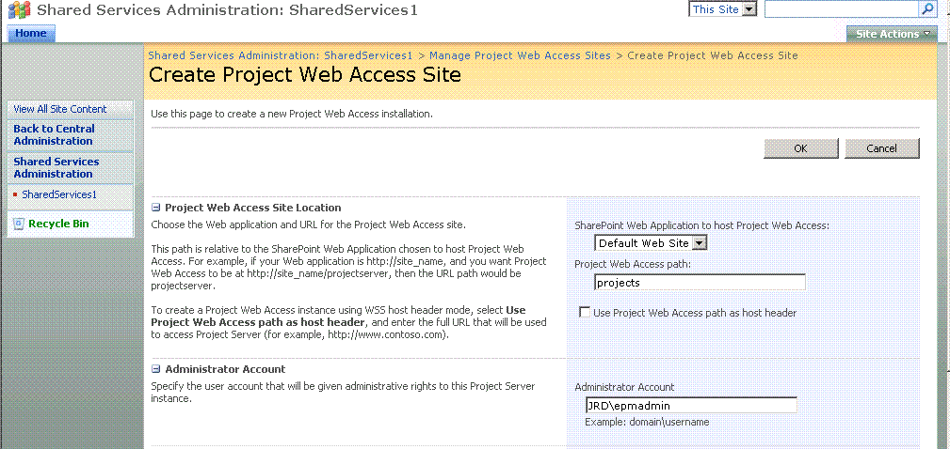

- In the Administrator Account section, type the Windows user account that will be given administrative credentials to the Project Server instance.

- In the Primary and Reporting Database sections, do the following:

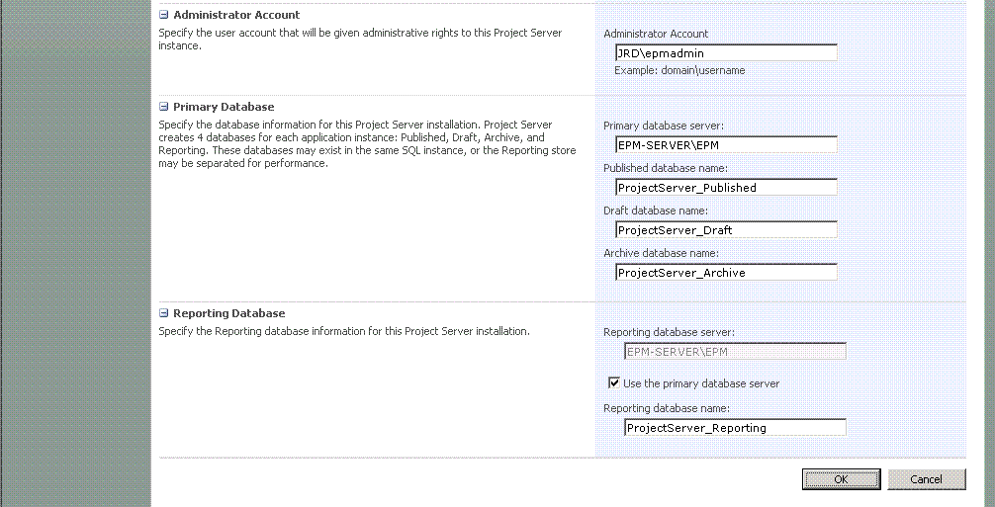
In the Primary Database Server field, type the name of the computer running SQL Server on which the Published, Draft, and Archive databases will be located.
In the four Database Name fields, enter unique names for each of the four Office Project Server 2007 databases.
Note You can use the default database names. However, make sure they do not already exist on the SQL Server.
In the Reporting Store field, type the name of the computer running SQL Server on which the Reporting database will be located. By default, it will list the same computer as the primary database server.

- Click OK. The provisioning process starts.

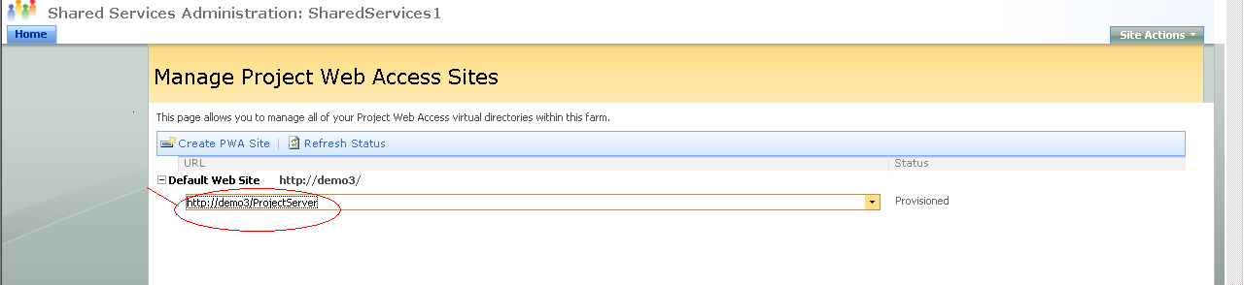

- You will return to the Manage Project Web Access page. Click the Refresh Status button to update the status of the provisioning process. When provisioning is complete, an entry in the Status column will display Provisioned. When completed, you can click the URL to go to the Project Web Access site.

Note Provisioning is an asynchronous process, so it might take a few minutes before the job is complete.

Configure Microsoft Office Project Professional 2007

After Office Project Server 2007 is installed, you can configure Microsoft Office Project Professional 2007 and Office Project Web Access to connect to your instance of Office Project Server 2007. By default, Office Project Server 2007 uses Windows authentication, which means that when you initially connect with Office Project Professional 2007 or Office Project Web Access, you will be using a Windows account. When you make the initial connection to Office Project Server 2007, you must be logged on as the Windows user who installed Office Project Server 2007. Use this account to initially create other user accounts that can access Office Project Server 2007.

Connecting to Office Project Server 2007 by using Office Project Professional 2007

Important Previous versions of Project Professional cannot connect to Office Project Server 2007.
You must use Office Project Professional 2007 if you want to connect to Office Project Server 2007.

After installing Office Project Professional 2007, you must create a Project Server account by which Office Project Professional 2007 can connect to Office Project Server 2007.

To connect to Office Project Server 2007 by using Office Project Professional 2007

- Open Office Project Professional 2007. On the Tools menu, select Enterprise Options, and then select Microsoft Office Project Server accounts.

- In the Project Server Accounts window, click Add.

- In the Account Properties window, do the following:

- In the Account Name box, type a unique name for this account.

- In the Project Server URL box, type the URL to connect to this instance of Office Project Server 2007.

- Click Test URL to verify that the Project Server URL to which you want to connect is available.

Note Clicking Test URL will only verify that the Project Server URL is valid. It will not test if the user account you are specifying in the next step is valid. Please verify that the account you are using is valid.

- In the When Connecting section, select one of the following:

- Use Windows user account This allows you to connect to Project Server by using the credentials of the Windows user that is currently logged on to the computer.

- This is the default setting.

Configure Microsoft Office Project Web Access

After Office Project Server 2007 is installed, you can configure Microsoft Office Project Web Access to connect to your instance of Office Project Server 2007. By default, Office Project Server 2007 uses Windows authentication, which means that when you initially connect with Office Project or Office Project Web Access, you will be using a Windows account. When you make the initial connection to Office Project Server 2007, you must be logged on as the Windows user who installed Office Project Server 2007. Use this account to initially create other user accounts that can access Office Project Server 2007.

To connect to Office Project Server 2007 by using Office Project Web Access

To add the Project Server sites to the list of trusted sites

- On the computers on which you will install Windows SharePoint Services and Project Server, open Internet Explorer.

- On the Tools menu, select Internet Options.

- Click the Security tab, and then click the Trusted site icon.
- Click Sites.

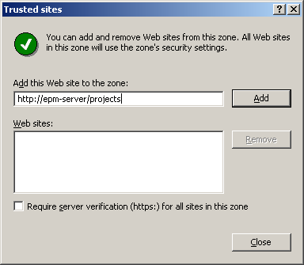

- Type the URL for the site (http://server name) that you want to add, and then click Add.

- Click Close, and then click OK.

- Access the EPM server URL : http://epm-server/projects

Backup and Restore Project Server 2007

Introduction

This will guide you through the Microsoft Office Project Server 2007 backup and restore process by using the SharePoint Central Administration Web site.

Set up a file share

If you do not already have a remote file share to store the backup files, you must set one up before backing up your environment.

Set up a remote file share

- (Recommended) Make sure SQL 'Setup server account' is using a domain account; see SQL Server books online on how to do it.
- Verify that the remote file share can be accessed from both the SQL Server computer and the computer that is hosting Central Administration.
- On the remote file server, create a directory and share it out. Be sure to give it access permissions for the account you will be using to backup and restore.
- On the Share Permissions tab of file share properties, grant the accounts listed below, Change and Read rights.
- On the Security tab of the file share Properties; grant the accounts listed below all the rights except Full Control.

Create required accounts

Accounts needed:

- SQL server account (if “Local system” is the SQL service account, you must grant permission to the SQL server computer.)
- Login account (required to do backup and restore using the command prompt).
- The Windows SharePoint Services 3.0 front-end server account, such as <domain>\<server name>$ (required to do backup and restore using the user interface).
- The central administrator pool account (required to do backup and restore using the user interface).
- The Timer service account (requested by UI).

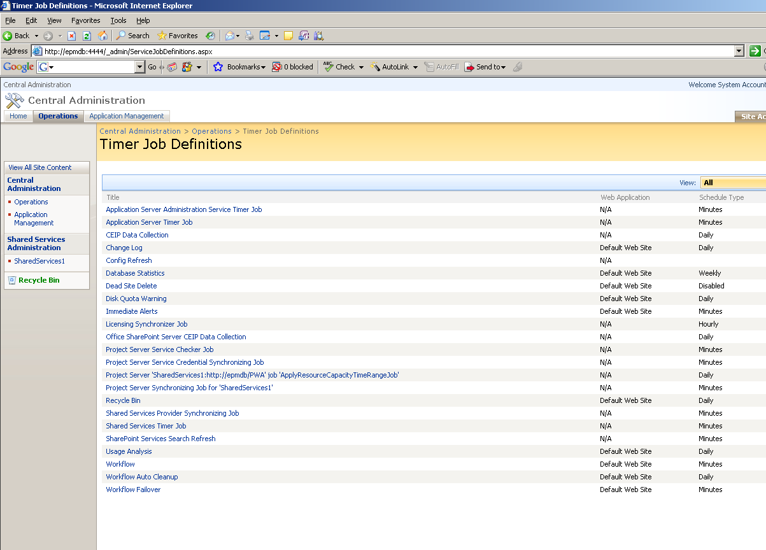

Note The central administrator pool and the Timer service use the same user account.

Note If you receive any errors during the backup or restore process, you must delete the failed “Backup/Restore” timer job before you can run the next backup or restore process. The URL for the Timer service jobs is:
http://<adminsite:port>/_admin/ServiceJobDefinitions.aspx.

Note You do not have to delete the Timer service job if you did the Project Server 2007 backup or restore by using the stsadm.exe command-line tool.

Note The server farm should be taken offline prior to backup.
Back up your environment

To back up your Project Server 2007 installation, do the following:

- Navigate to Central Administration; the URL looks like http://<server_name>:port/default.aspx.
- Click Operations on the top navigation bar.
- In the Backup and Restore section of the Operations page, click Perform a Backup.

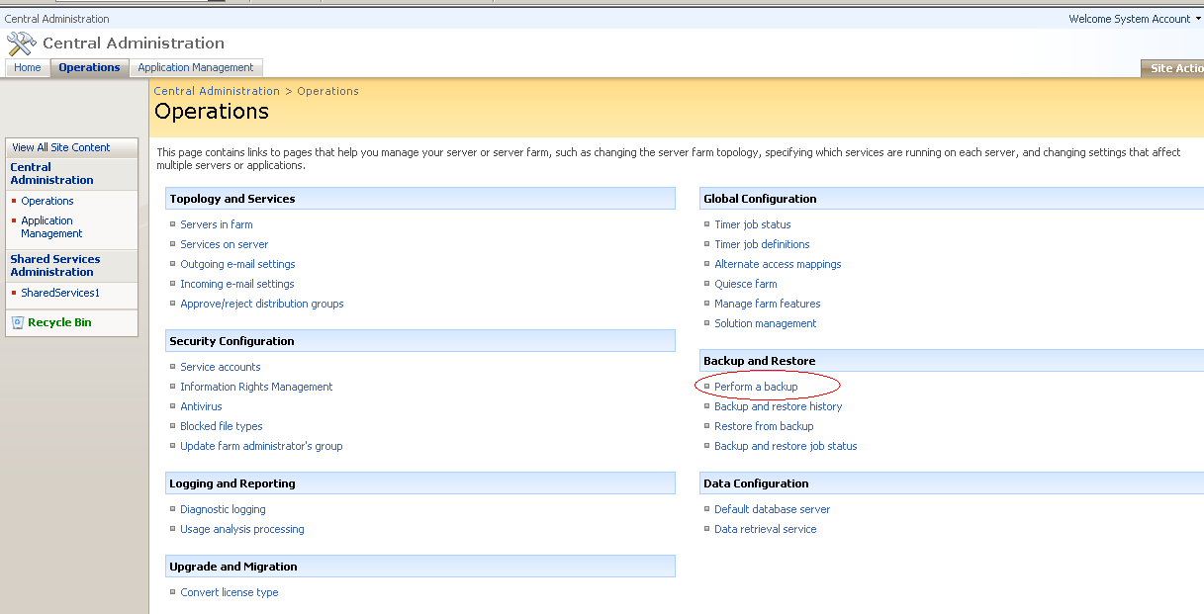

- On the Select Component to Backup page, choose the components you want to back up, such as Farm or an individual site. You can select any one component and all components under it.

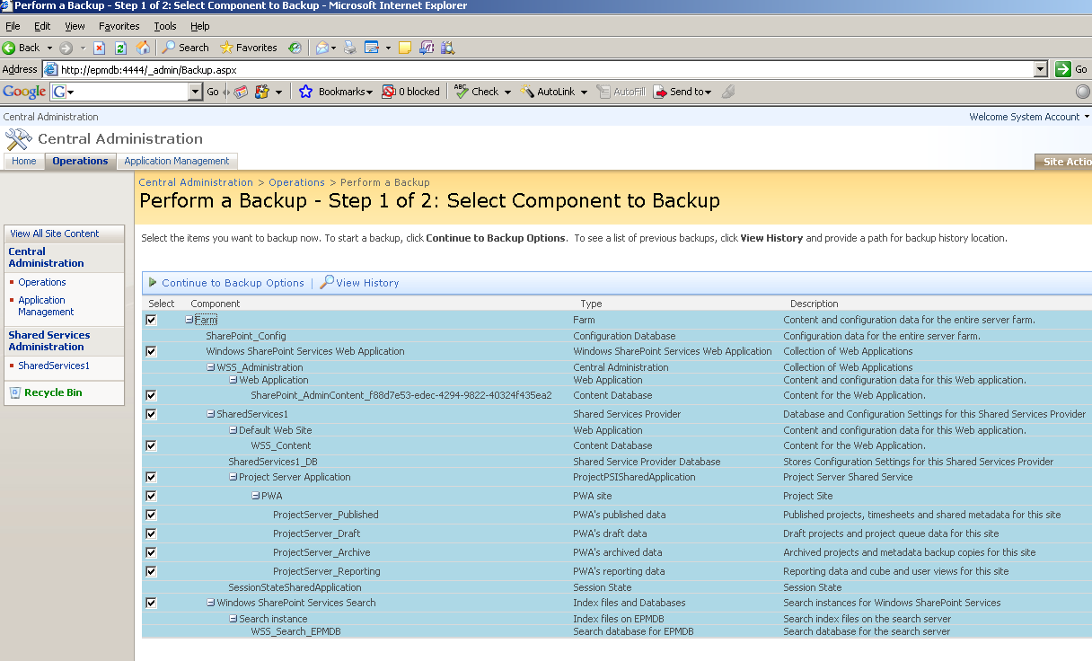

- When you have selected all the components you want to back up, click Start Backup Process. On the Start Backup page, under Backup File Location, enter the UNC path to the backup folder.

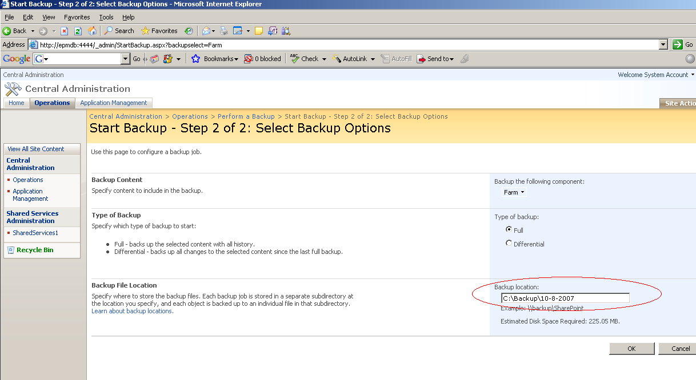

- Click OK
- You can view the backup job status on the backup status page, by clicking Refresh. The page will also refresh every 30 seconds automatically. Backup and Restore is a Timer service job, so it may take few seconds for the backup to start

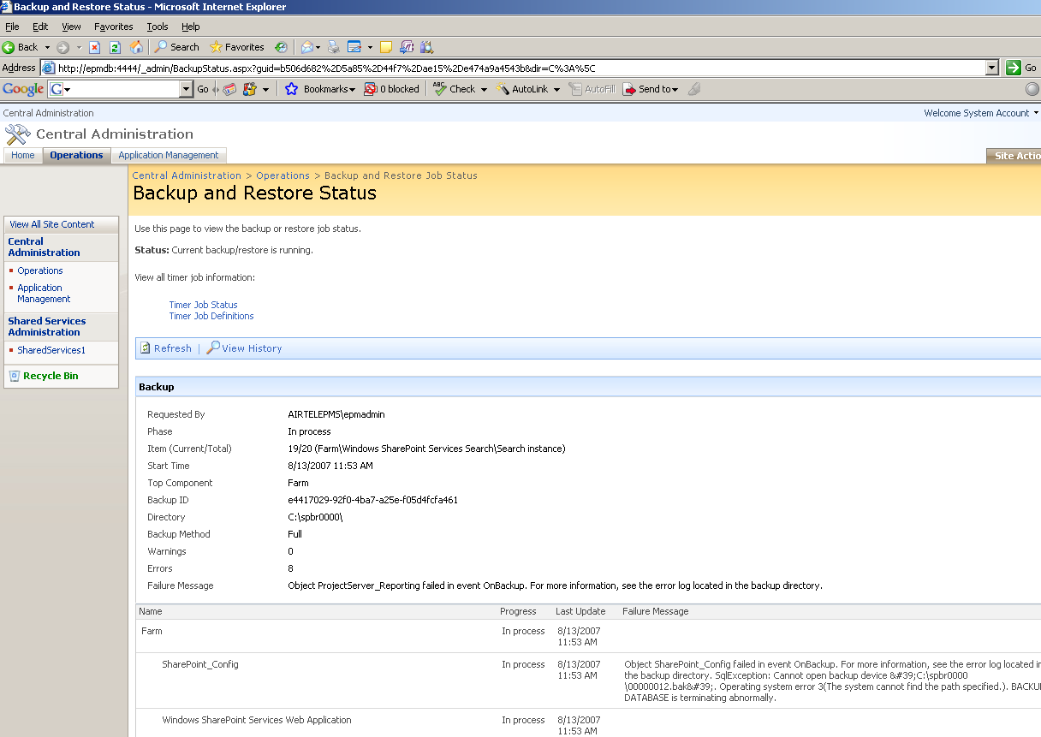

- If you receive any errors, you can find more information by looking in spbackup.log at the UNC path you specified above

Restoring a Project Server 2007 deployment

This section guides you through the Microsoft Office Project Server 2007 restoration process using Central Administration. It describes how to restore over the original server farm. This document does not describe a migration of Project Server 2007 data.

Restore to the original farm

- Navigate to Central Administration; the URL looks like http://<server_name>:port/default.aspx.

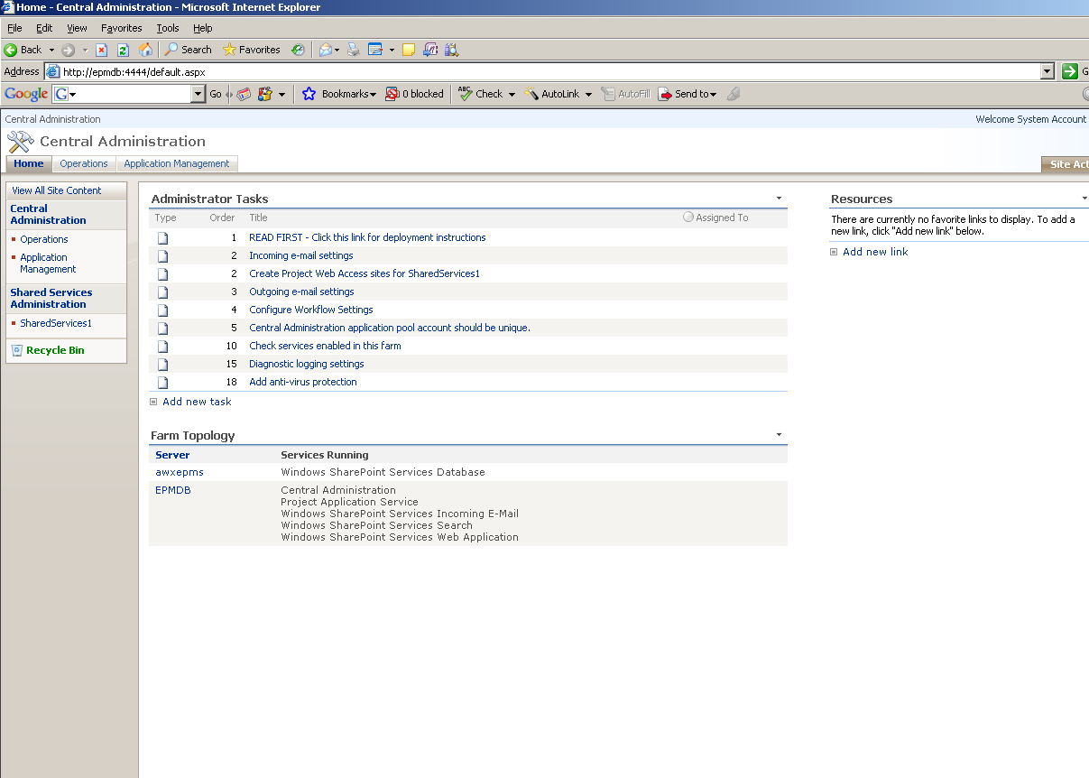

- Operations on the top navigation bar.
- In the Backup and Restore section of the Operations page, click Restore from backup.

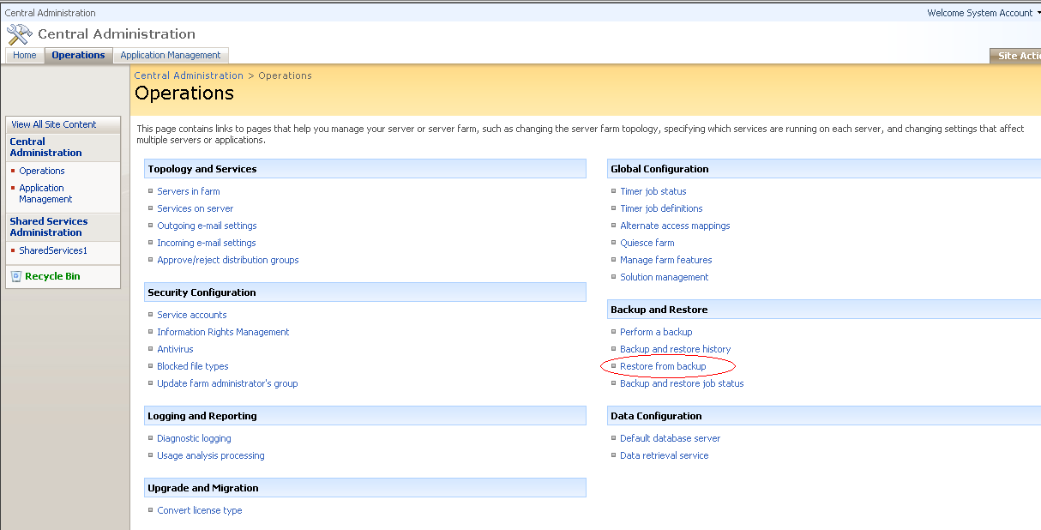

- On the Restore from Backup: Step 1: Select Backup File page, under Backup File Location, enter the UNC path to the backup folder.

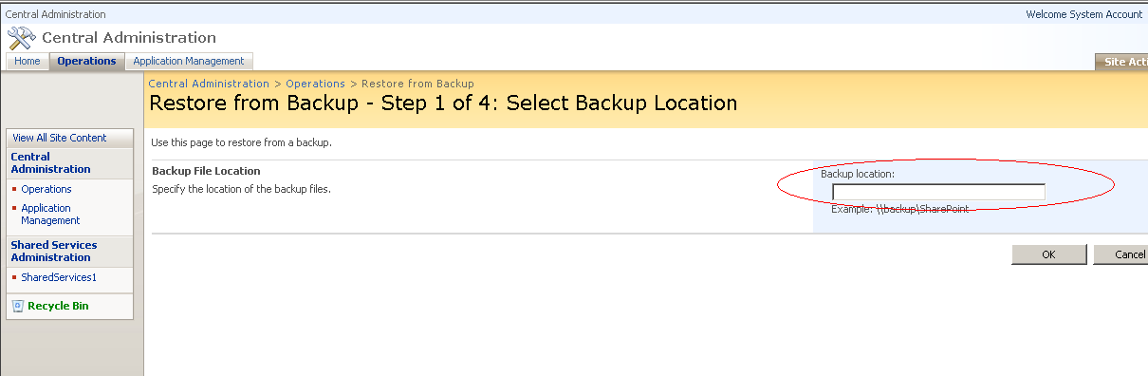

- On the Restore from Backup: Step 2: Select Backup Package to Restore page, choose the target backup package and click Start Restore Process.

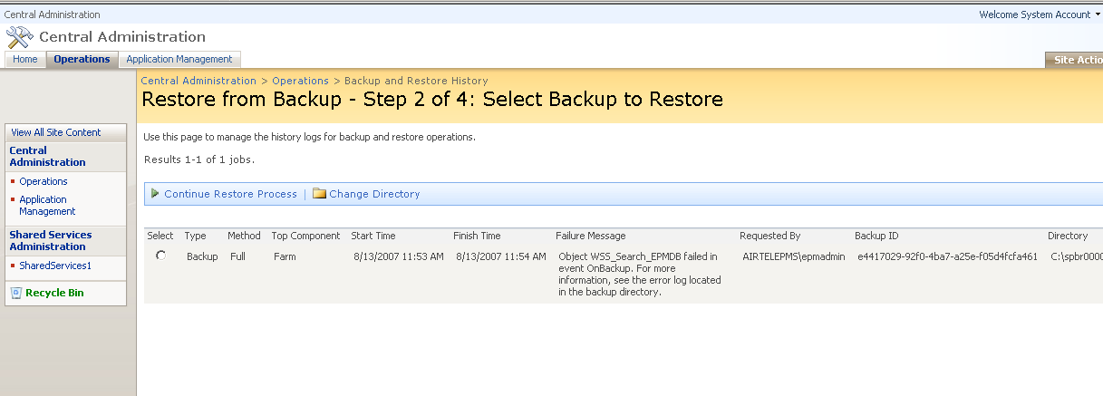
- On the Restore from Backup: Step 3: Select Component to Restore page, choose the restore level (Farm, Service, Database or SSP) and click Start Restore Process.

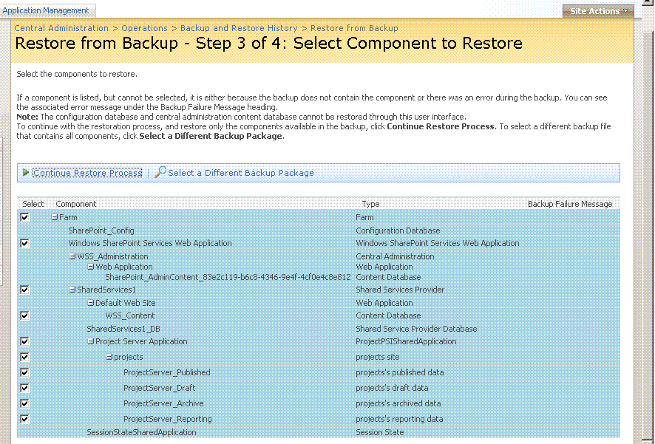

- On the Restore from Backup: Step 4: Select Restore Options page, select Overwrite (Create new is the default value) and click OK in the pop-up dialog.

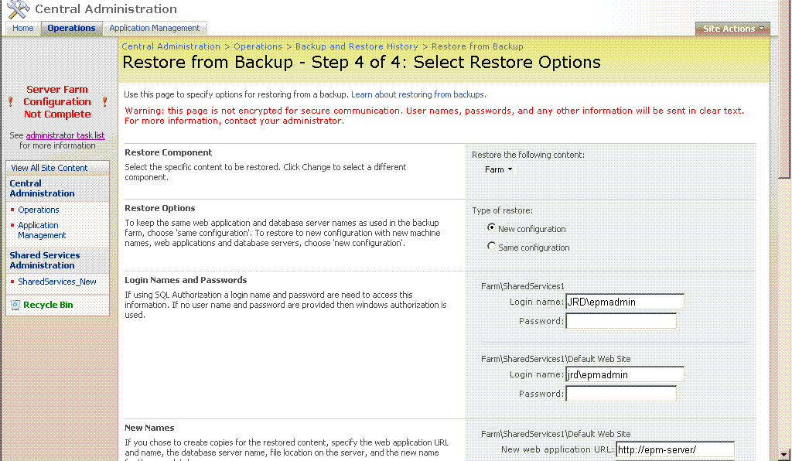

- Under New Names, enter the user name and password for the Web applications listed on the page.

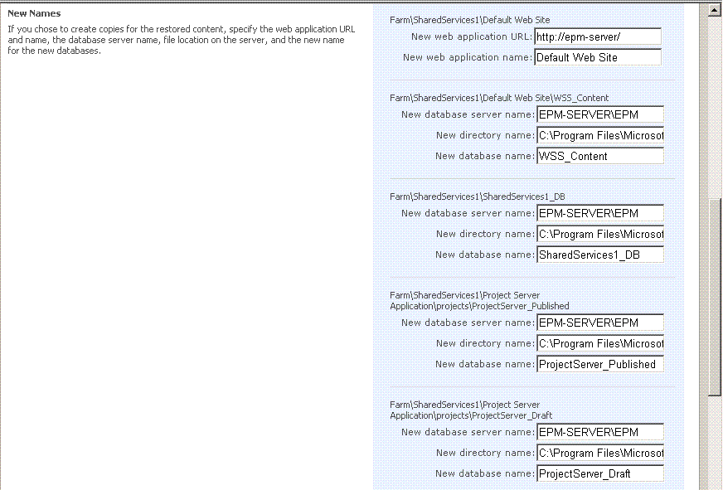

- Click OK.
Online Office Project Server 2007 Help

Product evaluation for Office Project Server 2007
- Planning and architecture for Office Project Server 2007
- Determine organization and user needs (Project Server)
- Plan EPM Solution architecture (Project Server)
- Plan site structure and navigation (Project Server)
- More...
Deployment for Office Project Server 2007
- Migration guide for Office Project Server 2007
- Deploy Office Project Server 2007 with Office SharePoint Server 2007
- Configure Office Project Server 2007 to use the Cube Building Service
- More...
Operations for Office Project Server 2007
- Manage security in Project Server 2007
- Managing timesheets in Microsoft Office Project Server 2007
- Administering backup and recovery for Project Server 2007
- More...
Security and protection for Office Project Server 2007
Troubleshooting for Office Project Server 2007
Technical reference for Office Project Server 2007
Central Administration Help (Project Server 2007)
Articles

Newly published content for Office Project Server 2007
Downloadable books for Office Project Server 2007
Development for Office Project Server 2007
Downloadable book: Cube Building Service in Office Project Server 2007
Downloadable book: Understanding and Using the Queuing system in Office Project Server 2007
Downloadable book: Managing timesheets in Microsoft Office Project Server 2007

